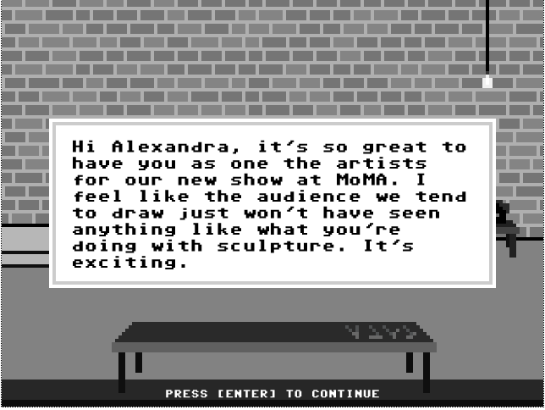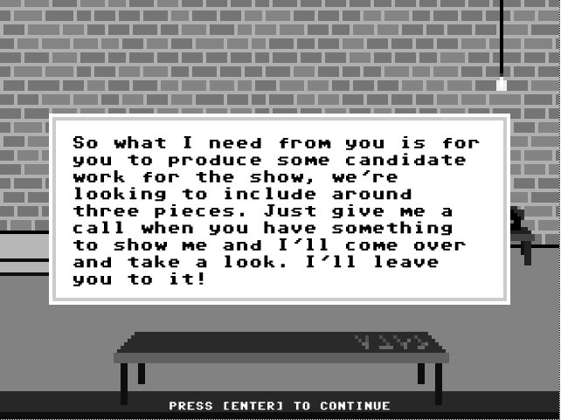
I think these need the same sort of repositioning and I assume the performance people too. The curator loves the work but wants new work for the show. That is what usually happens anyway.
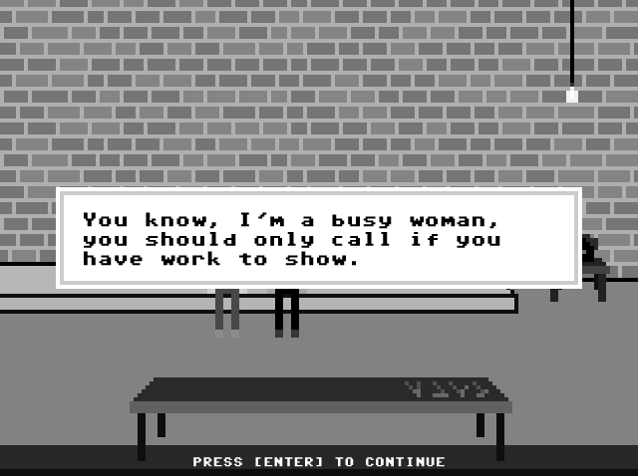
Third time lucky…
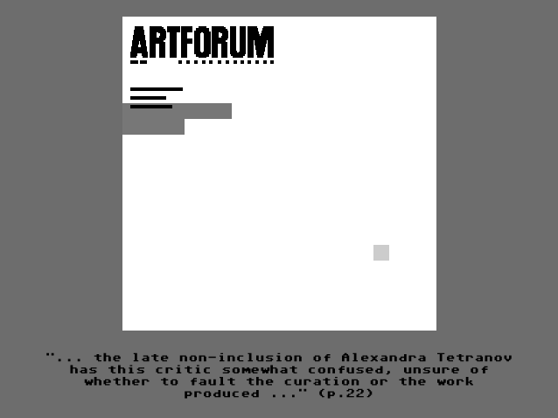
I’ve said it before and will no doubt say it again, you are a funny guy.
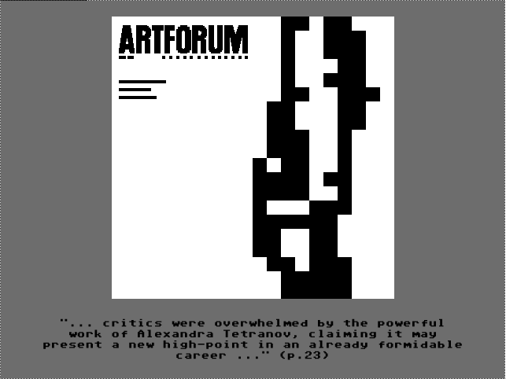
Nice.

This is just great, my favourtite is making the sculpture.
So subject to other comments it’s a winner.

